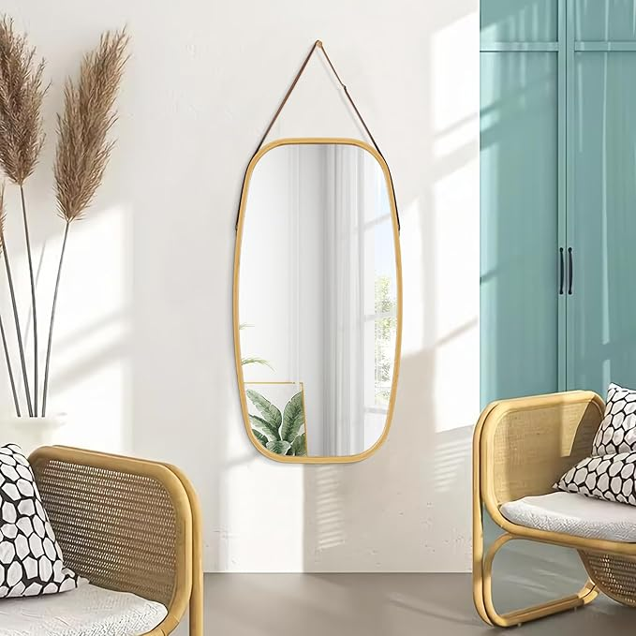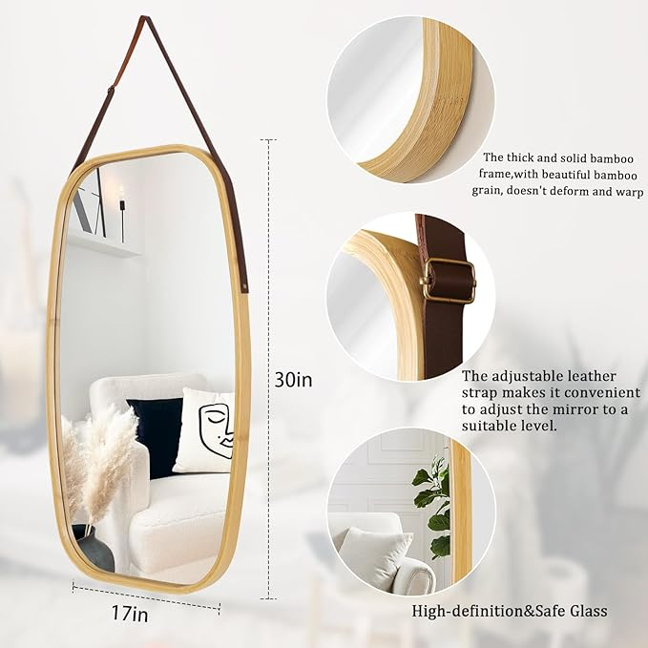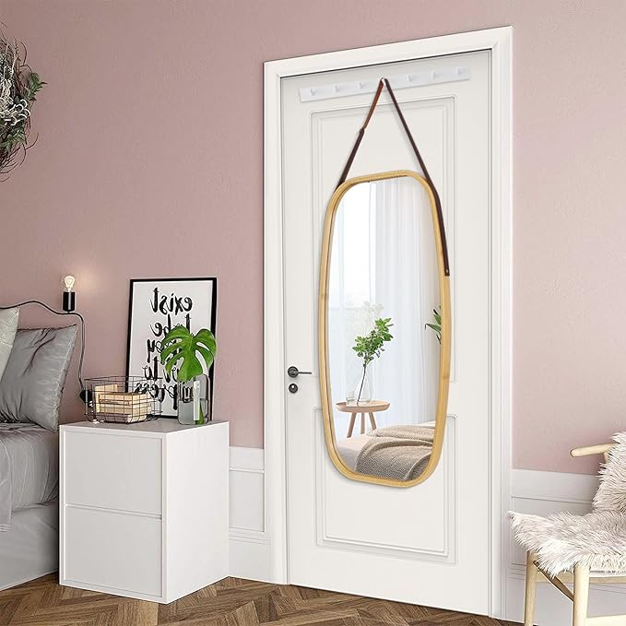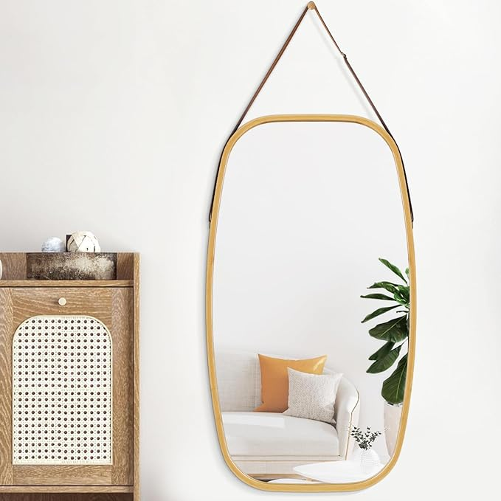

AAZZKANG Rustic Mirror Rectangle Hanging Mirror with Wood Frame 30"x17" Large Wall Mirror for Bedroom Living Room Dressing Room

**PRODUCT DESCRIPTION:**

|  |  |
| --- | --- |
| Brand | AAZZKANG |
| Room Type | Entryway, Dressing Room, Bathroom, Living Room, Bedroom |
| Shape | Rectangular |
| Product Dimensions | 30"L x 17"W |
| Frame Material | Wood |

**About this item**

* Sturdy Frame: The hanging mirror is constructed by superior frame,the thickened frame with round corner makes sure the sturdiness and durability without easy deforming and cracking
* HD Glass: High-definition,clear glass, provide distinct and lifelike image and well-lit reflection;The glass mirror is secured and embedded in the frame and reinforced with solid backing for added stability.Crafted of thick
* Easy to Use: The leather strap of the hanging mirror is adjustable, convenient to adjust the mirror to a suitable level to anyone,or directly placed on the table;Round nail head hook is included to hang the mirror on wall
* Large Hanging Mirror: 30" length,17" width,and looks fabulous for any wall.The size allows you to easily change its placement
* All-Match: This modern style rectangular mirror and eye-catching decor is better to your living room, bedroom, bathroom,dorm,dressing room,office and anywhere, this is not only a mirror,but also an ornament